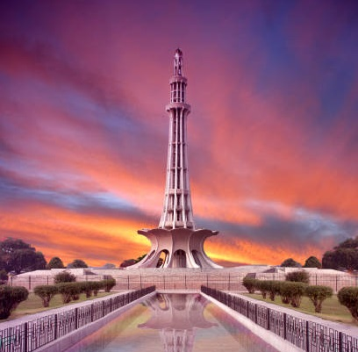­

**Minar -E- Pakistan**

Soaring symbol of Pakistan's birth, Minar-e-Pakistan stands tall in Lahore's heart.

**History**

Towering symbol of independence, built where Pakistan's future rose from the Lahore Resolution.